Guided walk round Little Venice and canal boat cruise to Camden Lock – 8th September 2009

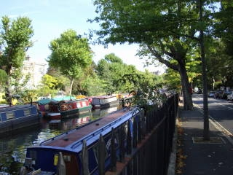
The day started cool and cloudy but by the time we reached Little Venice, it had become sunny and hot, just as it always seems to be on Hedfas visits. Our guides from London Walks, Andy and Richard, led us through the elegant streets of Little Venice, pointing out the houses of the great and good: Freud, JK Rowling, Joan Collins, Lily Langtry, Ben Gurion, Canaletto and Masefield to name but a small selection. There were plenty of Blue Plaques to be seen, and one house even had two.
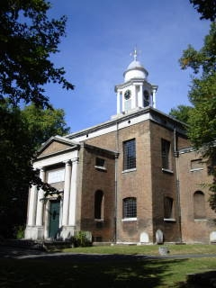

A unique combination of white stucco, gardens and canals, it boasts the finest early Victorian architecture in London. We were privileged to be able to go inside lovely St Mary’s Church and to rest awhile whilst admiring its beauty and serenity.

After finding lunch in some of the many pubs and canal side cafes, we boarded the narrow boat “Jason” for a trip on the Regent’s Canal. “Jason” was built from wood and metal more than 100 years ago and was a working barge until converted for tourism. The onboard guide explained the history of the canal, reminding us that there are more than 4,000 miles of inland waterways in Britain. The canals fell into dereliction once the railways and roads took their place as the transport systems, but are being restored and increasingly used for a variety of purposes.

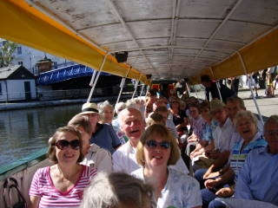
We passed the zoo, the power station and many gardens before arriving at buzzy Camden Lock, where hippies and tourists alike browsed the stalls and cafes. Just time for a quick cuppa before our coach home. Time to muse on the coach at 70mph on the contrast between the 18th century canal (speed limit 4mph) and the 21st century ten lane motorway!

Diana Brimblecombe Visit organised by Liz Crompton

