The visit to Charleston House Farm and Farley Farm had been eagerly anticipated by me and I was very disappointed at the ticket sales. Well the visit did go ahead and it was brilliant, one of the best and well worth the early rise, the long journey and the cost.

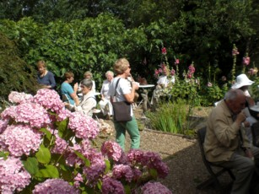
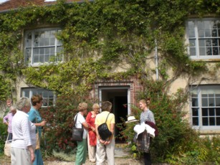
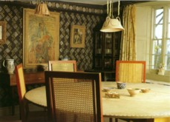
We left at 07 30 and arrived in glorious sunshine at Charleston before 10 00 and had coffee and biscuits inside or in a beautiful courtyard surrounded by hollyhocks. We then went in three groups around the house. All the guides were excellent and we heard all about Vanessa Bell ( sister of Virginia Wolfe ) and her husband Duncan Grant. The relationships were rather complicated and we all marvelled at the memories of the guides. The art work inside the house was very varied. Much of the furniture and walls and doors had been decorated in the style of Italian Fresco and Post Impressionist painting. It was quite unique. The writers and artists who visited Charleston Farm in the 1900’s reads like a “Who’s Who” of 20th Century art and literature. The surrounding garden were a picture.

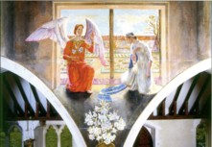

We left for the Cricketers at noon in the village of Berwick. We had a lovely lunch and then we all visited the church to look at the murals painted by Vanessa Bell and friends. They were quite stunning, and very much in keeping with a small village church. The church alone is well worth a visit.

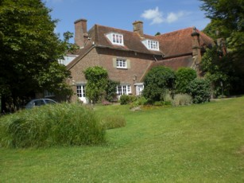
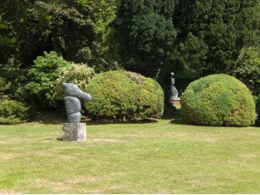
We arrived at Farley Farm at 14 30 and again were very warmly welcomed. We went into two groups, one went round the house while the other looked at a local art exhibition and the gardens. The farm house was full of treasures in unexpected places. There was a Picasso tile above the cooker in the kitchen! There were also two other Picasso's in the kitchen. We saw Roland Penrose’s work including the one he did of Lee Miller just after he met her. I love that one; others will have their favourite also. Lee Miller’s camera that she carried with her during the Second World War plus all the other bits of equipment she needed were on display. We also saw some of her photographs of the concentration camps, and much more.

At the end of our visit we unexpectedly met by Anthony Penrose who had spoken to us at HEDFAS recently and many of us chatted with him for some time. He is a lovely man! The journey home was long, but no one cared as we all had had such a wonderful day
.
This is a visit I would recommend to all NADFAS groups. It is in some respects what the society is all about. If you are in the area then go. If you need to go on the M25 then grit your teeth and do it. You will not regret it.

Liz Crompton

